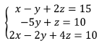
Example 1: Solve the system of linear equations by elimination

Example 2: Solve the system of linear equations by elimination
